CHROMEBOOK TIPS & TRICKS

Getting To Know The Keyboard
The design of your Chromebook is little different from traditional notebooks. The first
difference that you will notice is the keyboard. Chromebooks do not have a caps lock key. Instead of function keys, you have dedicated keys for managing your Chrome browser. Getting used to this may take a while. But once you get the hang of it, I am sure you will enjoy it.
So what do you need to know to make the best out of the Chromebook keyboard?
Here is the first thing for you to do. Press CTRL + ALT + ? and you will see all the available
keyboard shortcuts.

The Search Key and Caps Lock Key
The caps lock key has been replaced with a search key. The search key opens the Chrome OS
apps menu. Chrome OS Apps Menu is quite useful. Refer to Chrome OS Apps Menu section of
this guide for more information.
To get your capslock key back, go to settings and search for Keyboard. From keyboard settings,
you can change the function of the search key to capslock.
But personally, I like the search key and when I REALLY need caps lock on, I use the following
keyboard shortcut.

ALT + SEARCH
Use this keyboard shortcut to enable or disable capslock. When capslock is turned on, you will
see a up arrow like icon on the next to time on the taskbar.

No Delete Key
Yes, there is no delete key in most Chromebooks. Here is the keyboard shortcut you will use.
ALT + Backspace - Delete the next letter (forward delete)
CTRL + Backspace - Delete the previous word

No Home or End Keys
Alternate keyboard shortcuts are;
Home - ALT + Up Arrow key
End - ALT + Down Arrow key

Dedicated Brower Keys
We talked a lot about things that you won’t see on a Chromebook. Now lets talk about things
you get extra on your Chromebook’s keyboard.
Instead of function keys (F1 to F12, remember?) Chromebook gives you dedicated browser
keys, or keys that you can use to perform some actions that you do on the browser. The
following is a list of dedicated browser keys that you get.
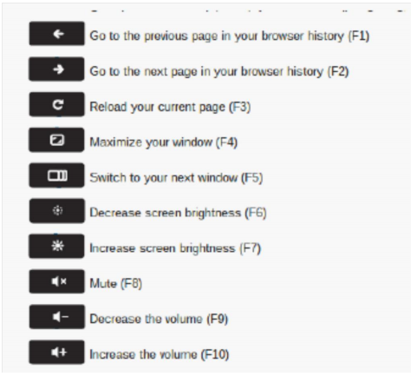

Some Trackpad Tricks
1. Click or tap with two fingers for right click
2. Swipe with two fingers for scrolling

Chrome OS Apps Menu
For starters, the Chrome OS Apps Menu is similar to the start menu on windows. You can open
the apps menu by clicking the apps icon on the taskbar or pressing the Search key.
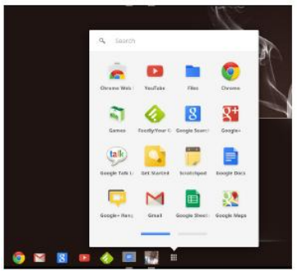
From the Apps Menu, you can:
Launch apps you have installed from Chrome Web Store: Click the app icon from
the menu, and the app will launch on a new tab. Right click the app icon for more
options like, adding the the app to the taskbar,or the launcher as they call it.
You can right click any app to remove it from your Chromebook.
Search the web: You don’t need to open a new tab, open Google.com and then type
in the search query. You are on a Chromebook now! Press the search key once to open
the Chrome OS apps menu, type in your query and hit Enter. A new tab will open with
your search results.
Do some basic maths or conversions: Since Google search is integrated to the
Chrome OS apps menu, you can do basic maths from the search area of the menu. Try
something now. For example, type in 4*4= and see what happens!

Taking Screenshots
Ctrl + takes screenshot of your current window
Ctrl + Shift + gives you more control. Use this to take a partial screenshot by
selecting the area you want to capture

ALT + BACKSPACE
Do not waste time looking for Trash. There isn’t any! If you accidently deleted a file, click Undo
on the top of the file manager window to retrieve the file.
Cleaning your Chromebook
You can clean the screen with a clean soft t-shirt.
Never use any product containing any alcohol, ammonia, or other strong solvent to clean your
Chromebook.
Create a gentle cleaning solution comprised of 50% water and 50% white vinegar.
Disconnect the Chromebook from power and ensure it is off – this means SHUT DOWN.
Apply the solution to a cotton cloth, lint free microfiber, chamois, or some other very soft cloth.
Clean in small circular motion.
Use a can of compressed air to blow any dust or foreign particles from under the keyboard.

Charging question
You do not have to run the battery down to 10% once a week, but you shouldn’t leave them plugged in all the time either.

Keyboard shortcuts picture